Interpreting Data Import Results
  - Blackboard Connect
If you choose to keep your data updated via imports (as opposed to manually adding, editing, or removing contacts), you will want to know how to interpret import results. You can export the errors up to 5 days after the import occurs (go to Recipients > Import Data > Import History > click down arrow on left > click the number next to Warnings or Rejected). See the screenshot below for reference.
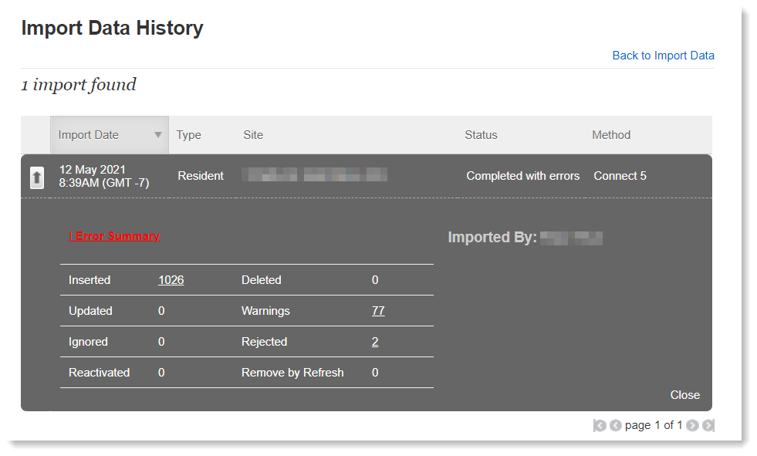
In the results export, it will indicate the row number on which the issue was found. Note that the header row is not accounted for in this row number, so when looking at your original import CSV, add one to the row number listed to find the record that had the issue. (Example: Results say row 100 had an invalid email address—look at row 101 in your CSV.)

Shown under Rejected:

Needs Review, Action Required
- You do not have authority to modify data for {unrecognized Institution} or the Institution code is not mapped in Connect. Please contact Connect Support at 888-599-2720. – In the Institution column, make sure you are using your full site name. If you need to use an abbreviation or code instead, add it under Admin > Sites > click pencil icon to edit site > click Modify button under Data Source Code.
- Minimum required data was not provided and your contact is rejected. – A record must have at least one contact point (a phone number, email address, or SMS number). If no contact points are available, the entire record is rejected (not imported).
  - To fix: Locate the rejected record in the file, add at least one contact point, and reupload.
- No data provided in LastName - this is a required field for ContactType= {student/faculty/staff/admin/other/prospect/resident} – The entire record was rejected because no last name was provided, and this field is required for most types. (GOV clients: LastName is not required for type Business—BusinessName is required instead.)
  - To fix: Locate the rejected record in the file, add the last name, and reupload.

Shown under Warnings:

Needs Review, Action May Be Required
- Invalid phone provided. – Phone numbers must be 7 or 10 digits. If not, the field is rejected.
  - To fix: Locate the invalid phone in the file, correct it, and reupload.
- Invalid Email provided. – Emails must take the form of ___@___.___. If there are invalid characters (such as a comma, hashtag, ampersand, apostrophe, etc.), if the @ is missing or there are multiple @ symbols, or if there are two emails in a single field, the email address will be rejected.
  - To fix: Locate the invalid email address in the file, correct it, and reupload.
- Invalid SMS provided. SMS Phone rejected. – SMS number must be 7 or 10 digits. If not, the field is rejected.
  - To fix: Locate the invalid SMS phone in the file, correct it, and reupload.
- Invalid State provided : . Contact address rejected. The entire address is rejected if the state is invalid.
  - To fix: Locate the invalid state in the file, correct it, and reupload.
- Duplicate rows in import. One row processed, other ignored – For the purpose of weeding out duplicate records, Connect looks at First Name, Last Name, phone numbers, and email addresses. If all of these match, the record is only imported once and duplicates are rejected. Note that address is not one of the fields considered.
  - This typically does not need to be fixed, however, if you need multiple of the same contact, here is how to fix: Give each record a unique REFERENCECODE or make the first or last names different from each other.

Typically Does Not Need Review, No Action Required
- PrimaryPhone field empty or invalid but other phone data available. PrimaryPhone remapped to first available phone field. – If you do not specify a PrimaryPhone, Connect will use Phone1. If Phone1 is empty, it will use Phone2, and so on.
- Phone number is only seven digits. Used institution’s area code. – 10 digits are required to dial a phone number, so if we only see 7 digits, we will append the area code of your institution.
- Invalid Zip provided - must be 5 or 9 digits. Field rejected. – Zip codes must be 5 or 9 digits. If not, the zip code is rejected but the rest of the address still imports. Connect can typically still resolve the address to a longitude/latitude for geolocation (necessary when selecting recipients by drawing a shape on a map.)

